**Carriageworks Theatre Access Information Guide**

Leeds City Council aims to provide an accessible and inclusive facility for all events taking place in the Carriageworks Theatre.

The main entrance to the theatre is situated on Millennium Square within The Electric Press. You will find our ticket office, Leeds Ticket Hub, here on the ground floor. From the entrance on Great George Street, through The Electric Press Courtyard, there are 6 steps to the ground floor ticket office and a lift to all levels.

Lift access is available to all levels: -0, Ground Floor and Levels 1 – 4.

An accessible (M/F) toilet with baby change facilities is available on levels 1,2,3 & 4

Bars on Level 1 and Level 2 are open to visitors prior to and during performances.

The Main Auditorium has eleven wheelchair spaces available on Level 1.

The Studio, a small-scale black box space, on Level 4, has four wheelchair spaces available, dependant on layout.

Support Dogs are welcome. Water bowls supplied.

**Tickets**

Accessible tickets can be bought online at [Leeds Ticket Hub](http://www.leedstickethub.co.uk) or over the phone on [0113 376 0318](tel:0113%20376%200318).

Tickets can also be purchased or collected in person from the ticket office on the ground floor from two hours before any show begins at The Carriageworks Theatre.

Audio Described, BSL Interpreted, Captioned, Dementia Friendly and Relaxed Performances can be booked online at [Leeds Ticket Hub](http://www.leedstickethub.co.uk). We recommend contacting our Ticketing team on [0113 376 0318](tel:0113%20376%200318) to discuss any specific requirements you may have before booking.

Wheelchair spaces cannot currently be booked online.

**Hearing enhancements**

A hearing loop is available for the Main Auditorium (Rows F-M provide optimum reception) and The Studio. To request a headset in advance please email [Leeds Ticket Hub](mailto:boxoffice@leeds.gov.uk) or call [0113 376 0318](tel:0113%20376%200318).

**British Sign Language**

Each year our annual Panto includes BSL performances. Please visit the Panto booking page or email [Leeds Ticket Hub](mailto:boxoffice@leeds.gov.uk) for details.

**Essential Companion Scheme**

The Essential Companion Scheme offers two tickets for the price of one to theatregoers with disabilities and their essential carers. Documentation of eligibility is required to access the scheme. For further information please email [Leeds Ticket Hub](mailto:boxoffice@leeds.gov.uk) or call [0113 376 0318](tel:0113%20376%200318).

**Contact**

For all event accessibility enquiries please contact:

Leeds Ticket Hub  
Email: [tickets@leeds.gov.uk](mailto:tickets@leeds.gov.uk)  
Tel: [0113 376 0318](tel:01133760318)  
Carriageworks Theatre,

The Electric Press,

Millennium Square,

Leeds, LS2 3AD

All access-related enquiries will be responded to within 3 working days.

Carriageworks Theatre access information is available to download in pdf and word format below.

**Parking**

Street parking and secure car park options available nearby include:

1. **Portland Crescent Car Park** pay and display short stay. Located off Portland Crescent near Leeds Civic Hall, Portland Crescent. Open all day with a maximum stay of 5 hours before 6pm.
2. [**The Light Multi Story Car Park**](https://www.q-park.co.uk/en-gb/cities/leeds/poi/the-light/)long stay open 24 hours, 7 days a week. Located via Dudley Way off Great George Street on the Leeds City Loop.
3. [**St. John’s Shopping Centre Multi Story Car Park**](https://stjohnsleeds.co.uk/information/parking.php)long stay. Open 24 hours, 7 days a week. Located off Merrion Street on the Leeds City Loop.,
4. [**Woodhouse Lane Multi Story Car Park.**](https://www.leeds.gov.uk/parking-roads-and-travel/parking/city-centre-car-parks/woodhouse-lane-car-park)Open 24 hours, 7 days a week. Located opposite Leeds Metropolitan University, with access from the inner ring road.

**Drop Off**

The Carriageworks Theatre can be accessed from Great George Street (LS1 3DW), through the Electric Press courtyard entrance. Due to on-going roadworks, we recommend you visit the [alternative routes](https://leedscitystation.commonplace.is/proposals/plan-ahead-alternative-routes/step1) page for the most up to date road access across Leeds City Centre.

Access to the Theatre from Great George Street

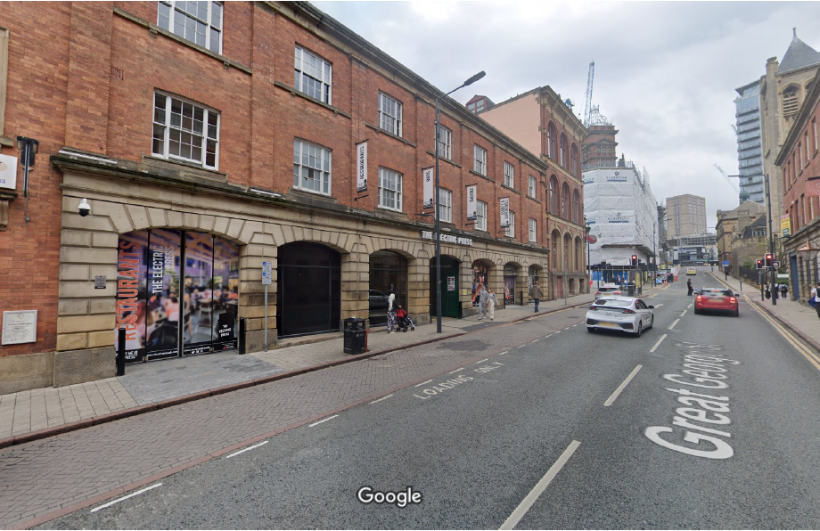

Access to the Theatre from Millennium Square

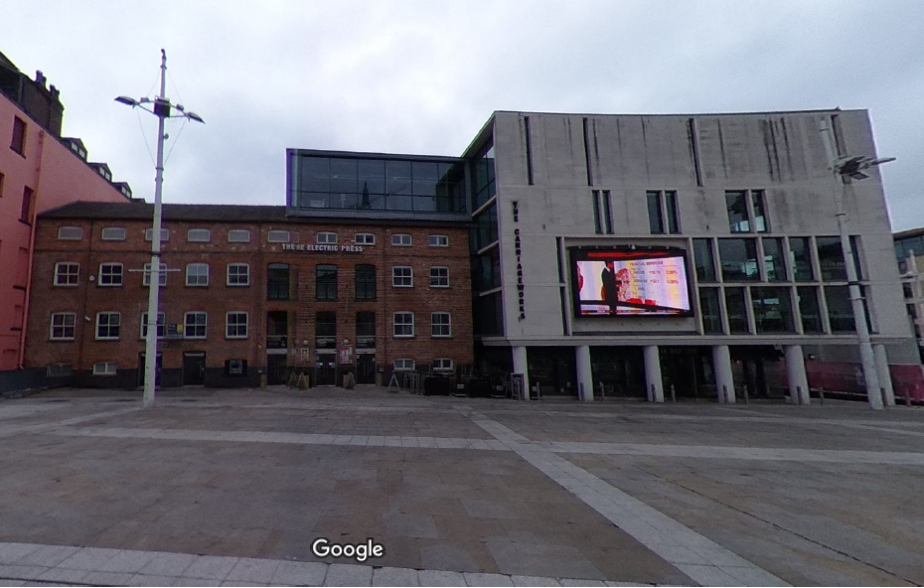

**Rail Links**

Leeds City Train Station is ten minutes’ walk from the Carriageworks Theatre (located in the Electric Press Development) and Millennium Square.

**Bus Links**

Several bus routes pass through the city centre. For bus services and timetable information please contact West Yorkshire Metro: 0113 245 7676 or visit the website for West Yorkshire Travel Information: [www.wymetro.co.uk](http://www.wymetro.co.uk)