Group bookings information pack

Carriageworks Theatre
Information Pack & Risk Assessments

This guide provides information on the Carriageworks Theatre for the organisers of group bookings for theatre performances. Our aim is to make your visit a safe, comfortable, and enjoyable one.

If you require any further information after reading the guide, please do not hesitate to contact us on 0113 378 7132 or email carriageworks@leeds.gov.uk.

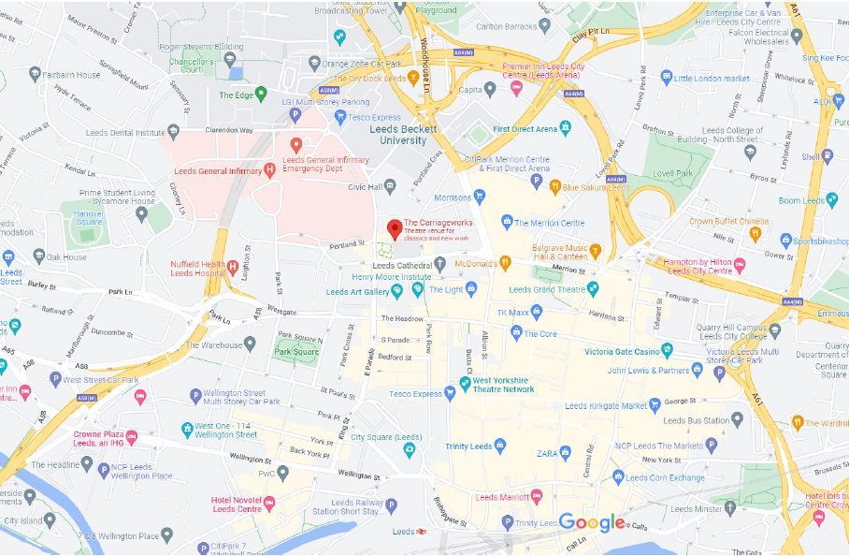

Parking

Street parking and secure car park options available nearby include:
- Portland Crescent Car Park pay and display short stay. Located off Portland Crescent near Leeds Civic Hall, Portland Crescent. Open all day with a maximum stay of 5 hours before 6pm.
- The Light Multi Story Car Park long stay open 24 hours, 7 days a week. Located via Dudley Way off Great George Street on the Leeds City Loop.
- St. John’s Shopping Centre Multi Story Car Park long stay. Open 24 hours, 7 days a week. Located off Merrion Street on the Leeds City Loop.
- Woodhouse Lane Multi Story Car Park. Open 24 hours, 7 days a week. Located opposite Leeds Metropolitan University, with access from the inner ring road.

Drop Off
Carriageworks Theatre can be accessed from Great George Street (LS1 3DW), through the Electric Press courtyard entrance. Due to on-going roadworks, we recommend you visit the alternative routes page for the most up to date road access across Leeds city centre.

Access to the theatre from Great George Street:
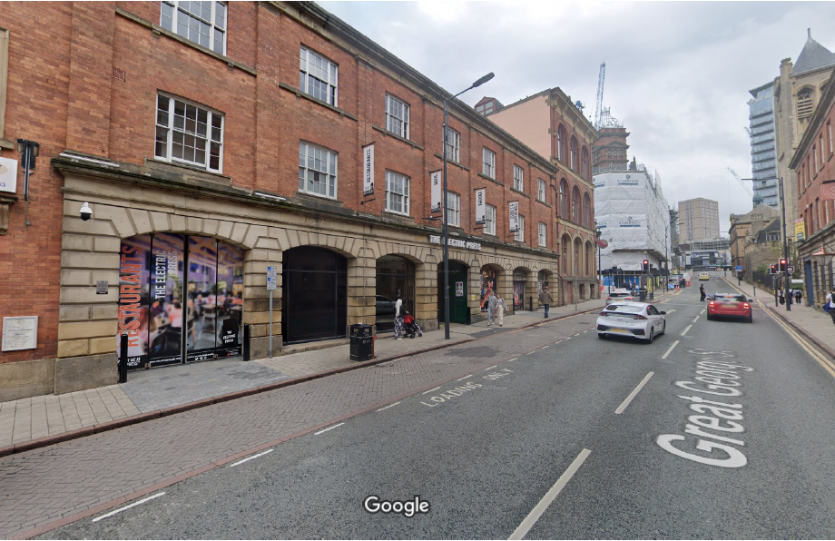
Access to the theatre from Millennium Square:
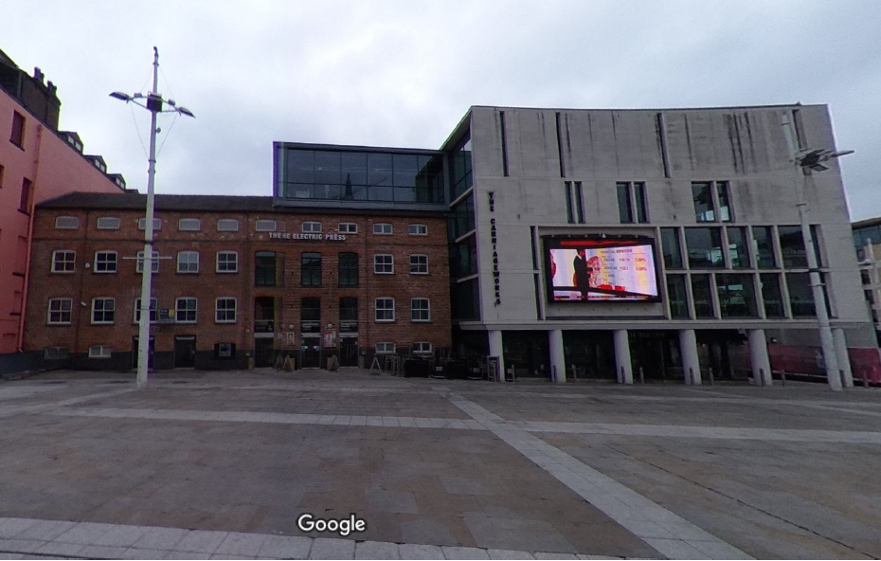

Rail Links
Leeds Train Station is ten minutes’ walk from the Carriageworks Theatre (located in the Electric Press development) and Millennium Square.
Bus Links
Several bus routes pass through the city centre. For bus services and timetable information please contact West Yorkshire Metro: 0113 245 7676 or visit the website for West Yorkshire Travel Information: www.wymetro.co.uk

Theatre Layout

The theatre is situated over four floors. Please familiarise yourself with the location of emergency exits on arrival.

The box office is on the ground floor as you enter the Electric Press building from Millennium Square.
The main auditorium can be entered at levels 1, 2, or 3. Your tickets will indicate the level at which you should enter the auditorium.

Our studio theatre is situated on the fourth level.

There are accessible toilets at every level of the theatre. The main facilities are on level 2.

BUILDING INSURANCE

Leeds City Council maintains Public Liability Insurance, Insured by Zurich Municipal policy number QLA-03G036-0353.

Building Systems

There are comprehensive maintenance and testing regimes for fire alarm systems, disabled toilet alarms, fire extinguishers and all mechanical and electrical systems within the building.
Fire exits and corridors are checked daily.

Building SUPERVISION & Staffing

A duty manager is present whenever the building is open to the public. There is also CCTV for your safety.

Stewarding will be provided at the ratio of at least one steward per 250 patrons, increasing to at least one steward per 100 patrons where the audience consists of young persons or other patrons with high support needs. Stewards have had appropriate training in evacuation procedures and awareness training on child protection.

Please let us know if anyone in your group has any other requirements not covered in this information pack.

Child Protection

All Carriageworks Theatre staff receive training on child protection. If you have any concerns during your visit, please inform the duty manager at once.

Emergency Evacuation

In the case of an evacuation, the alarm will sound; this is a loud two-tone siren, accompanied by flashing red lights. In the main auditorium during a show an announcement will be made asking patrons to vacate the building. Your party should leave by the nearest available exit. Exits are clearly marked with the green ‘running man’ sign.

The assembly point is at the top end of Millennium Square adjacent to the Leeds City Museum. Theatre staff will assist in evacuating the building, but it is your responsibility to keep your group together and carry out a head count once clear of the building. If you have lost any member of your party please inform the duty manager.

You must not re-enter the building until given clearance to do so by the duty manager.

Special Requirements

If your party has visitors with disabilities or needing other assistance, please inform us at the time of booking. If necessary, we may need to meet before your visit to ensure that appropriate safety measures are in place and to draw up an evacuation plan tailored to your specific needs. Although our staff are fully trained, it is essential that you provide appropriate companions for persons with high support needs.

For your convenience we have the following facilities:

Disabled Evacuation Lift
In the event of an evacuation, patrons who are unable to use the stairs can use our lift which has a specially protected power supply. There are refuge points on each level which are clearly marked. There is an intercom on the wall by the lift where you can ask for assistance from a member of staff. There are also evacuation chairs available on each level. These will be operated by a trained member of staff.

Induction Loops
We have infra-red hearing units in the main auditorium and in the Carriageworks studio space. Please ask for neck loops at the Box Office.

Toilet Facilities
We have wheelchair accessible toilets on every level.

Wheelchair Spaces in the Auditorium
Please indicate when booking if you need level access or if any of your group wishes to remain in their wheelchair. This enables us to ensure that we provide you with the best possible service. Our designated wheelchair spaces are on level 1.

Theatrical effects
We will display advisory notices where smoke or strobe lighting effects will be used during a performance. Please ask for details at the time of booking if this is likely to be a concern for anyone in your party.

.......and finally

We hope that you enjoy your visit to the Carriageworks Theatre. If you have any questions prior to your visit, please contact us.

We welcome feedback, if there is any comment you wish to make after your visit please do so.

Address: Carriageworks Theatre
The Electric Press
3 Millennium Square
Leeds
LS2 3AD
Carriageworks Theatre Operations Team: 0113 3786993
Leeds Ticket Hub Team (Box Office): 0113 3760318
tickets@leeds.gov.uk
Email: carriageworks@leeds.gov.uk
Web: www.carriageworkstheatre.co.uk

